**REXINE STORE MANAGEMENT SYSTEM**

A Project Report

Submitted in Partial fulfilment of the

Requirements for the award of the Degree of

**BACHELOR OF SCIENCE (COMPUTER SCIENCE)**

By **SHEHZAD HUSAIN AIJAZ HUSAIN SHAIKH**

**Roll Number :** **462**

Under the esteemed guidance of

**Prof. Omprakash**

**Assistant Professor**



**DEPARTMENT OF COMPUTER SCIENCE**

**GURU NANAK KHALSA COLLEGE**

**OF**

**ARTS, COMMERCE & SCIENCE (Autonomous)**

**MATUNGA, MUMBAI – 400 019**

**MAHARASHTRA**

**AY 2024 – 2025**

**GURU NANAK KHALSA COLLEGE OF ARTS, COMMERCE & SCIENCE**

**(Autonomous)**

**MATUNGA, MUMBAI, MAHARASHTRA – 400 019**

**DEPARTMENT OF COMPUTER SCIENCE**



**CERTIFICATE**

This is to certify that the project entitled, **“REXINE STORE MANAGEMENT SYSTEM”**, is benefited work of **SHAIKH SHEHZAD HUSAIN AIJAZ HUSAIN** bearing **Roll No. 462** submitted in partial fulfilment of the requirements for the award of degree of **BACHELOR OF SCIENCE in COMPUTER SCIENCE from University of Mumbai**

**Project Guide HOD**

**External Examiner**

**Date of Submission : College Seal**

**ACKNOWLEDGEMENT**

I owe special thanks to the Department of Computer Science of **Guru Nanak Khalsa College Of Arts, Commerce & Science (Autonomous)** for giving me a chance to prepare this project dissertation. I thank the Coordinator and Head of the Department **Dr. Jasmeet Kaur Ghai** for providing us the required facilities and guidance throughout the course which culminated into this thesis. Last and not the least to the project guide this semester**- Professor Omprakash.** Deep gratitude to the staff and faculty of Guru Nanak Khalsa College for their help and support. And also, my beloved **Parents** and **Classmates** for their infinite support and love.

**SYNOPSIS**

**REXINE STORE MANAGEMENT SYSTEM**

Store Management System Application

[Using Python Tkinter and db browser (sqlite)]

**INTRODUCTION**

The Rexine (artificial leather) store management system is a software solution designed to streamline the operations of a store that deals with Rexine products. Rexine, also known as artificial leather or faux leather, is a popular material used in various industries, including fashion, upholstery, automotive, and more. Managing inventory, sales, and customer information efficiently is essential for a Rexine store to ensure smooth operations and customer satisfaction. The Store Management System for Rexine Create aims to optimize the inventory management and sales processes of Rexine. Create a store specializing in rexine (artificial leather) products.

The Rexine store management system provides a comprehensive platform to handle all aspects of the store's operations, including inventory management, sales tracking, customer management, vendor management, and reporting. By utilizing this system, store owners and managers can enhance their efficiency, reduce manual work, and make informed decisions for business growth.

It is an system application. It help to mange the store by computer By checking online stock of the rexine products available, and help to make the bill for customer by making bill with application and handed to the customer.

Store management system help to maintain the stock of the products . Store management system is better than writing on a paper or book about stock of the rexine product. Making bills get easy by store management system application and it is less time consuming.

**OBJECTIVES**

1. **Inventory Management:** The primary objective of the Rexine store management system is to ensure efficient inventory management. This includes tracking stock levels, monitoring product variations, managing supplier information, and facilitating timely stock replenishment.
2. **Vendor Management:** The objective of the system is to facilitate effective vendor management. It aims to maintain supplier information, track pricing agreements, manage delivery schedules, and foster smooth communication with suppliers.
3. **Accurate Reporting and Analytics:** The objective of the store management system is to provide accurate and insightful reporting and analytics capabilities.
4. **Integration and Scalability:** The objective is to provide a flexible and scalable solution that can integrate with other software systems.
5. **Data Security and Integrity:** The objective is to ensure the security and integrity of the data stored within the system.

Automate inventory tracking and replenishment to avoid stockouts and optimize storage space.

Implement a sales management module to facilitate order processing, invoicing, and sales analysis.

Enhance customer experience through personalized service and efficient order fulfilment.

By using system application it is less time consuming for checking about stock or making bill for the customer.

**SCOPE**

The scope of the Rexine store management system encompasses various aspects of managing a store that deals with Rexine products. It includes the following key areas:

**1. Inventory Management:**

* Tracking and managing Rexine product variations, stock levels, and supplier information.
* Automated stock replenishment and reordering to maintain optimum inventory levels.

**2. Sales and Billing:**

* Generating invoices, managing sales orders, and handling discounts or promotions.
* Integration with payment gateways to facilitate secure and convenient payment options.
* Tracking sales transactions, order history, and generating sales reports.

**3. Vendor Management:**

* Managing vendor information, including supplier details, pricing agreements, and delivery schedules.
* Streamlining procurement processes, tracking supplier performance, and managing purchase orders.

**4. Integration and Scalability:**

* Integrating with other systems such as accounting software, e-commerce platforms, or POS systems.

**5. Data Security and Backup:**

* Implementing data security measures to protect sensitive customer information and business data.
* Regular data backups and recovery strategies to ensure data integrity and minimize data loss risks

**METHODOLOGY**

* **Requirement gathering:** Conduct interviews and discussions with Rexine Create stakeholders to understand their needs and expectations from the system.
* **System design:** Create a detailed system architecture and considering the specific requirements of the store.
* **Development:** Implement the system using appropriate programming languages and frameworks.
* **Testing and debugging:** Conduct rigorous testing to ensure the system is functional, secure, and error-free

**TOOLS AND TECHNOLOGIES**

* **Programming languages:**

Python Tkinter: Tkinter is the inbuilt python module that is used to create GUI applications. It is one of the most commonly used modules for creating GUI applications in Python as it is simple and easy to work with.

* **Database management system:**

DB Browser(sqlite) : SQLite is a lightweight and embedded database management system that is well-suited for small to medium-sized store management systems.

* **Operating System: window 11**

It's important to note that the choice of tools and technologies may vary based on specific project requirements, development team expertise, and scalability needs.

**TIMELINE**

* **Requirements gathering:** July-August.
* **Feasibility Study:** July-August.
* **System design:** August-September.
* **Technology Section:** September-October.
* **Development:** September-October.
* **Final Review:** October

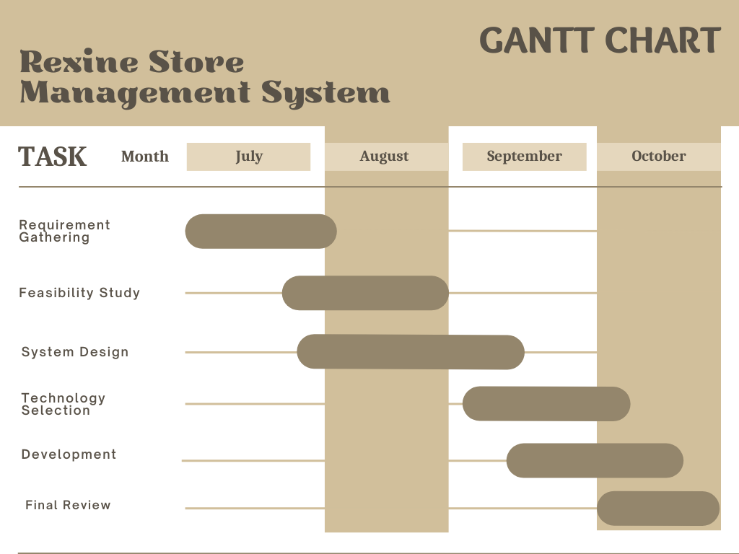

**RESOURCE**

Building a Rexine (Artificial Leather) Store Management System requires a combination of technical knowledge and domain expertise. Here are some key resources that can help you in the development process:

**SQLite:**

SQLite Documentation: The official SQLite documentation provides information on using and managing SQLite databases.

**Tkinter (GUI development):**

Python's Tkinter Documentation: The built-in Tkinter documentation can help you get started with GUI development in Python.

Online tutorials, courses, and community forums can also be helpful in understanding specific concepts and addressing challenges during development.

The developer should have knowledge of software developments, database and UI/UX design.

The project will require hardware infrastructure for development and testing, including servers and network equipment.

Additionally, the Developer will collaborate with key stakeholders from the retail business to gather requirements and provide feedback throughout the development process.

Hardware: Servers, computers and networking equipment.

# ABSTRACT

The **Rexine Store Management System** is an innovative software solution designed to streamline and enhance the operations of rexine and leather goods stores. In today's competitive retail landscape, efficient management of inventory, sales, and customer relationships is paramount. This software system aims to address these challenges by providing a user-friendly interface and a comprehensive set of features tailored specifically for rexine store owners and managers.

Key features of the Rexine Store Management System include inventory management, sales tracking, supplier management, customer relationship management, and reporting capabilities. With this system, store owners can easily monitor their stock levels, track sales trends, manage supplier relationships, and provide superior customer service. The intuitive user interface ensures that users, regardless of their technical proficiency, can navigate the system effortlessly, saving time and increasing productivity.

Additionally, the Rexine Store Management System offers real-time analytics and reporting tools, allowing store managers to make data-driven decisions. By analyzing sales patterns, identifying popular products, and predicting demand, store owners can optimize their inventory, reduce costs, and maximize profits. The system also includes features for customer engagement, enabling personalized communication and loyalty programs, which can enhance customer satisfaction and retention.

# DECLARATION

I hereby declare that the project entitled, **“**REXINE STORE MANAGEMENT

SYSTEM**”** done at **GURU NANAK KHALSA College of Arts, Commerce & Science,** has not been in any case duplicated to submit to any other university for the award of any degree. To the best of my knowledge other than me, no one has submitted to any other university.

The project is done in partial fulfilment of the requirements for the award of degree **BACHELOR OF SCIENCE (COMPUTER SCIENCE)** to be submitted as 5th semester project as part of our curriculum.

**Shaikh Shehzad Husain**



**TABLE OF CONTENT**

**CHAPTER 1. INTRODUCTION 1**

1.1 Introduction to the system 1

1.2 Problem Definition 2

1.3 Aim 3

1.4 Objective 3

1.5 Goal 4

**CHAPTER 2. REQUIREMENTS SPECIFICATION 5**

2.1 System Environment 5

2.2 Software Requirements 5

2.3 Hardware Requirements 5

2.4 Methodology 6

**CHAPTER 3. SYSTEM ANALYSIS 8**

3.1 System Analysis 8

3.2 Analysis of Existing System 9

3.3 Gantt Chart 10

**CHAPTER 4. SURVEY OF TECHNOLOGY 11**

4.1 PYTHON(Tkinter) 11

4.2 DB Browser(sqlite) 12

**CHAPTER 5. SYSTEM DESIGN 14**

* 1. Introduction 14
  2. System Architecture 15
  3. UML Diagrams 17

**CHAPTER 6. RESULTS 24**

**CHAPTER 7. CONCLUSION AND FUTURE SCOPE 40**

7.1 Conclusion 40

7.1.1 Advantages 40

7.1.2 Limitations 41

7.2 Future Enhancement 42

**CHAPTER 8. REFERENCES 43**

8.1 References 43

**Chapter 1. INTRODUCTION**

* 1. **Introduction to the System**

Rexine is a synthetic material often used in the manufacturing of items such as bags, paras, paras, upholstery, clothing, and more. Effective store management is essential for ensuring smooth operations, customer satisfaction, and profitability. Here's an introduction to rexine store management:

**1. Business Overview:**

Begin by introducing the rexine store and its primary focus, which is the sale of rexine and related products. Mention the range of products you offer, such as rolls of rexine, finished goods, or customized products.

**2. Inventory Management:**

Explain how you handle inventory, including sourcing rexine materials, tracking stock levels, and ensuring a variety of colors, patterns, and types are available to meet customer demands.

**3. Customer Service:**

Emphasize your commitment to excellent customer service, including how you assist customers in choosing the right rexine for their needs, providing product information, and addressing any inquiries or concerns.

**4. Sales and Marketing:**

Describe your sales and marketing strategies, both online and offline. Discuss any promotions, discounts, or loyalty programs that you offer to attract and retain customers.

**5. Future Plans:**

Briefly touch upon your future plans for the rexine store, whether it's expanding to new locations, diversifying product offerings, or embracing new trends in rexine materials.

**6. Conclusion:**

Summarize the key points of your rexine store management approach and convey your dedication to providing top-quality rexine products and services to your customers.

**1.2 Problem Definition**

The management of a rexine store is currently facing several operational challenges that hinder efficiency, customer satisfaction, and overall business growth. To address these issues and streamline operations, there is a need to develop a comprehensive Rexine Store Management System (RSMS).

Key Challenges:

**Inventory Management:** The store struggles to maintain accurate inventory records, leading to overstocking or understocking of rexine materials. This results in financial losses due to tying up capital in excess inventory or losing sales opportunities.

**Order Processing:** Order processing is largely manual, which is time-consuming and error-prone. This affects order accuracy and customer satisfaction, as delays and errors can occur.

**Customer Relationship Management:** There is no centralized system for managing customer information and preferences. This hinders targeted marketing efforts and personalized customer service.

**Supplier Management:** Lack of effective supplier management leads to difficulties in tracking deliveries, negotiating favorable terms, and maintaining consistent quality and pricing.

**Sales Tracking**: The store lacks a system to track sales performance, analyze trends, and make informed decisions regarding pricing, promotions, and product offerings.

**Employee Productivity:** Employee productivity is affected by the absence of digital tools and automation. Manual data entry and paperwork consume valuable time that could be better utilized in serving customers and growing the business.

**Security and Data Privacy:** The store lacks adequate security measures to protect sensitive customer information and business data.

* 1. **AIM**

The primary aim of a Rexine Store Management System (RSMS) is to modernize and optimize the operations of a rexine store, ensuring efficient management of rexine materials, improving customer satisfaction, and enhancing overall business performance. The specific aims of an RSMS include:

**Efficient Inventory Management**: To automate and streamline inventory control processes, ensuring the right rexine materials are available in the right quantities to meet customer demand while minimizing excess stock.

**Seamless Order Processing:** To expedite order processing, reduce errors, and enhance order accuracy, ultimately improving customer satisfaction and order fulfillment efficiency.

**Enhanced Customer Relationship Management:** To build and maintain a loyal customer base by storing and utilizing customer data effectively, allowing for personalized marketing, promotions, and exceptional customer service.

**Security and Data Protection**: To implement robust security measures that safeguard customer information and business data, ensuring compliance with data protection regulations.

**Business Growth and Competitiveness:** To create a foundation for sustained growth by optimizing operations, increasing customer satisfaction, and staying competitive in the rexine industry.

* 1. **Objective**

**Efficient Inventory Management**: To automate and streamline inventory control processes, ensuring the right rexine materials are available in the right quantities to meet customer demand while minimizing excess stock.

**Seamless Order Processing:** To expedite order processing, reduce errors, and enhance order accuracy, ultimately improving customer satisfaction and order fulfillment efficiency.

**Enhanced Customer Relationship Management:** To build and maintain a loyal customer base by storing and utilizing customer data effectively, allowing for personalized marketing, promotions, and exceptional customer service.

**Security and Data Protection**: To implement robust security measures that safeguard customer information and business data, ensuring compliance with data protection regulations.

**Business Growth and Competitiveness:** To create a foundation for sustained growth by optimizing operations, increasing customer satisfaction, and staying competitive in the rexine industry.

* 1. **GOAL**

The goals for a Rexine Store Management System (RSMS) are specific, measurable, and achievable targets that guide its development and implementation. These goals align with the objectives and aims of the RSMS and provide a clear direction for the system's functionality and impact. Here are some key goals for an RSMS:

**Optimize Inventory Control:**

Goal: Reduce excess inventory levels by 20% within the first year of implementing the RSMS.

Measure: Regularly monitor inventory turnover rates and stockout incidents.

**Enhance Order Processing Efficiency:**

Goal: Decrease order fulfillment time by 30% to improve customer satisfaction.

Measure: Track the time taken from order placement to delivery.

**Improve Customer Engagement:**

Goal: Increase customer retention rates by 15% through personalized marketing and service.

Measure: Analyze customer retention and repeat purchase rates.

**Chapter 2. REQUIREMENT SPECIFICATION**

* 1. **System Environment**

A Requirement Specification for a Rexine Store Management System (RSMS) outlines the detailed functional and non-functional requirements that the system must meet to effectively manage the operations of a rexine store. These requirements serve as a blueprint for system development and ensure that the RSMS aligns with the store's specific needs and goals.

The system environment for a Rexine Store Management System (RSMS) includes the hardware, software, network, and other components necessary to support the system's operation.

**Server:** A dedicated server or cloud-based hosting infrastructure is required to host the RSMS software and database. The server should have sufficient processing power, memory, and storage capacity to handle the system's demands.

**Barcode Scanners:** Barcode scanners may be used for efficient inventory management and order processing.

**Printers:** Printers are needed for generating invoices, packing slips, shipping labels, and other documents related to order fulfillment.

**2.2 Software Requirements**

* Technology: Python(tkinter)
* Visual studio: It use for Coding.
* Operating System: Microsoft Windows
* DB Browser(SQLITE): Its uses for Storing and managing database

**2.3 Hardware Requirements**

* Processor (CPU): Intel Core i3 (sixth generation or newer)
* Operating System: Microsoft Windows 10 Professional x64
* Memory: 8 GB RAM
* Storage: 500 GB internal storage drive
* Other: Internal or external Webcam, lock, carrying case, external hard drive for backups

**2.4 Methodology**

Developing a Rexine Store Management System (RSMS) involves a structured approach or methodology to ensure that the system is effectively designed, developed, tested, and deployed. Here's a commonly used methodology for developing an RSMS:

**1. Requirements Gathering:**

Start by gathering detailed requirements for the RSMS. This involves working closely with store management and end-users to understand their needs and objectives. Document functional and non-functional requirements, as well as any specific customization or integration needs.

**2. Feasibility Study:**

Conduct a feasibility study to assess the technical, operational, and financial feasibility of the RSMS project. Determine if it aligns with the store's goals and budget.

**3. System Design:**

Create a comprehensive system design based on the gathered requirements. This includes defining the system architecture, database schema, user interfaces, and integration points with other systems. Consider scalability, security, and performance at this stage.

**4. Technology Selection:**

Choose the appropriate technology stack for the RSMS, including the programming language, database management system (DBMS), and any third-party libraries or frameworks. Ensure that the chosen technologies align with the project's goals and constraints.

**5. Development:**

Start the development phase by creating the core components of the RSMS, including inventory management, order processing, customer management, and analytics features. Follow best practices for coding standards and documentation.

**6. Testing:**

Conduct thorough testing of the RSMS to identify and fix bugs, ensure system stability, and validate that it meets the specified requirements. Types of testing may include unit testing, integration testing, system testing, and user acceptance testing (UAT).

**7. Deployment:**

Deploy the RSMS in the production environment. Ensure that all necessary hardware, software, and network configurations are in place. Conduct data migration and perform final system checks before making it accessible to users.

**8. Final Review:**

Conduct a final review of the RSMS project to assess its success in meeting the defined objectives. Document lessons learned and best practices for future projects.

**Chapter 3. SYSTEM ANALYSIS**

**3.1 System Analysis**

System analysis for a Rexine Store Management System (RSMS) involves a comprehensive study of the existing system, identifying requirements, and proposing solutions to streamline operations, enhance efficiency, and meet the specific needs of the rexine store. Here's a breakdown of the key aspects of system analysis for an RSMS:

**1. Understanding Current System:**

Conduct interviews and meetings with store owners, managers, and employees to understand existing processes, workflows, and challenges. Identify manual and automated processes currently in use. Document the strengths and weaknesses of the current system.

**2. Requirement Gathering:**

Gather detailed requirements from stakeholders, including store managers, employees, and customers. Identify functional requirements (features the system must have) and non-functional requirements (performance, security, etc.).Prioritize requirements based on their importance to the business operations.

**3. Use Case Development:**

Create detailed use cases to describe how different users interact with the system. This includes scenarios for inventory management, order processing, customer interactions, etc. Use use cases to understand the system's behavior from an end-user perspective.

**4. Data Analysis:**

Analyze the types of data the system will handle (inventory data, customer data, supplier data, etc.). Determine data storage requirements and data relationships. Plan for data security, including encryption, access controls, and data backup procedures.

**5. Feasibility Study:**

Conduct a feasibility study to assess the technical, economic, and operational feasibility of the proposed RSMS. Evaluate if the benefits of implementing the RSMS outweigh the costs and potential risks.

**6. System Design Specifications:**

Create detailed system design specifications outlining the architecture, database schema, user interfaces, and integration points. Develop wireframes or prototypes to visualize the system's user interface and gather feedback from stakeholders.

**7. Risk Analysis:**

Identify potential risks related to technology, implementation, and user acceptance. Develop risk mitigation strategies to address identified risks.

**3.2 Analysis of Existing System**

Before we analyse the design of the proposed system, we need to carefully highlight the problems of the existing system so as to avoid recurrence. This analysis serves as a pointer on how to embark on building the proposed system that will help the women provide. The problems of the current system should be outlined. Below are some of the problems associated with the existing system.

In the existing system there is no monitoring system for girls, it should create many problems for them and the no safety mechanism to protect the girls from the misbehaviour activities. In addition, in the existing system there is no alert mechanism for the girl’s safety, it should be done by manually only

**3.3 GANTT CHART**



**Chapter 4. SURVEY OF TECHNOLOGY**

* 1. **PYTHON(Tkinter)**



Python's Tkinter library serves as a fundamental tool for creating graphical user interfaces (GUIs) in Python applications. Offering a straightforward and intuitive approach, Tkinter allows developers, especially beginners, to design interactive desktop applications with ease. It provides a wide range of widgets, including buttons, labels, and entry fields, enabling the creation of functional and visually appealing interfaces. Tkinter operates on an event-driven programming model, where user actions such as button clicks or keyboard input trigger specific functions, providing interactivity to applications. One of its significant advantages is its platform independence; applications developed using Tkinter can run seamlessly on various platforms, including Windows, macOS, and Linux. Integrated into Python's standard library, Tkinter ensures compatibility with other Python libraries and tools, facilitating seamless integration into diverse Python projects. While it may lack some advanced features found in specialized GUI libraries, Tkinter's simplicity and ease of learning make it an excellent choice for rapid prototyping and developing basic to moderately complex GUI applications. Its active community and extensive documentation provide valuable resources for developers, making it a popular choice for those venturing into GUI programming with Python.

DB Browser for SQLite, often simply referred to as DB Browser, is a powerful and open-source tool designed for managing SQLite databases. SQLite is a lightweight, file-based database engine widely used in various applications due to its simplicity and efficiency. DB Browser provides users with a user-friendly graphical interface to interact with SQLite databases, making it accessible to both beginners and experienced developers.

One of the key features of DB Browser is its intuitive interface, which allows users to create, edit, and manage SQLite databases visually. Users can design database schemas, define tables, modify data, and execute SQL queries, all through a convenient graphical user interface. This is particularly useful for those who prefer working with databases visually rather than writing complex SQL commands.

DB Browser also supports the import and export of data in various formats, facilitating easy data migration between different systems. It provides tools for analyzing database structures and querying data, enabling users to understand the relationships within their data effectively. Additionally, it supports the execution of complex SQL scripts, making it a versatile tool for developers working with SQLite databases.

Furthermore, DB Browser is a cross-platform application, available for Windows, macOS, and Linux operating systems. This platform independence ensures that users can seamlessly work with SQLite databases regardless of their operating system preference.

In summary, DB Browser for SQLite is a valuable tool for developers, data analysts, and database administrators, offering a convenient and user-friendly way to interact with SQLite databases. Its intuitive interface, data management features, and cross-platform compatibility make it a popular choice within the SQLite community.

* 1. **DB Browser(sqlite)**



DB Browser for SQLite, often simply referred to as DB Browser, is a powerful and open-source tool designed for managing SQLite databases. SQLite is a lightweight, file-based database engine widely used in various applications due to its simplicity and efficiency. DB Browser provides users with a user-friendly graphical interface to interact with SQLite databases, making it accessible to both beginners and experienced developers.

One of the key features of DB Browser is its intuitive interface, which allows users to create, edit, and manage SQLite databases visually. Users can design database schemas, define tables, modify data, and execute SQL queries, all through a convenient graphical user interface. This is particularly useful for those who prefer working with databases visually rather than writing complex SQL commands.

DB Browser also supports the import and export of data in various formats, facilitating easy data migration between different systems. It provides tools for analyzing database structures and querying data, enabling users to understand the relationships within their data effectively. Additionally, it supports the execution of complex SQL scripts, making it a versatile tool for developers working with SQLite databases.

Furthermore, DB Browser is a cross-platform application, available for Windows, macOS, and Linux operating systems. This platform independence ensures that users can seamlessly work with SQLite databases regardless of their operating system preference.

In summary, DB Browser for SQLite is a valuable tool for developers, data analysts, and database administrators, offering a convenient and user-friendly way to interact with SQLite databases. Its intuitive interface, data management features, and cross-platform compatibility make it a popular choice within the SQLite community.

**CHAPTER 5. SYSTEM DESIGN**

**5.1 Introduction**

The system design involves structuring the software architecture and components to efficiently manage various aspects of the store's operations. The system needs to address inventory management, sales tracking, customer interactions, and administrative tasks in a seamless manner.

Firstly, the database design is critical. It involves creating a database schema to store product information, including details such as product names, categories, prices, and available quantities. This database also includes customer information, sales transactions, and supplier details. Normalization techniques are employed to ensure efficient data storage and retrieval.

The user interface design focuses on creating an intuitive and user-friendly interface for both employees and customers. For employees, the interface includes functionalities for managing inventory, processing sales, and generating reports. For customers, it includes features for browsing products, placing orders, and tracking their purchase history. Visual elements, such as product images and intuitive navigation menus, enhance the user experience.

In terms of functionality, the system should incorporate features such as real-time inventory tracking, automatic restocking notifications, and sales analytics. Barcode scanning technology can be integrated to streamline the checkout process, reducing the chances of manual errors. A secure authentication and authorization system ensures that only authorized personnel can access sensitive information and perform specific tasks within the system.

Considering security, the system should implement encryption protocols to safeguard sensitive data, such as customer payment information. Regular security audits and penetration testing are essential to identify and address vulnerabilities.

Additionally, the system design includes scalability and performance considerations. The architecture must handle a growing database of products and customer information efficiently. Load balancing techniques and caching mechanisms can be employed to ensure the system performs optimally even during peak usage times.

Error handling and recovery mechanisms are integrated to manage unexpected system failures or data inconsistencies. Regular backups of the database are scheduled to prevent data loss and facilitate recovery in case of system failures.

Lastly, comprehensive documentation detailing the system architecture, database schema, user manuals, and troubleshooting guides is essential. It ensures that developers, administrators, and users have access to necessary information for system setup, maintenance, and usage.

In conclusion, the Rexine store management system's design encompasses database organization, user interface intuitiveness, robust functionality, security implementations, scalability provisions, error management, and thorough documentation. A well-designed system ensures efficient store operations, enhances user experience, and provides a solid foundation for future enhancements and expansions.

**5.2 System Architecture**

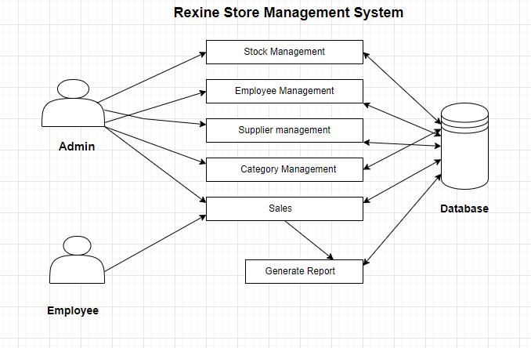

The system architecture is a crucial blueprint that defines the arrangement and interaction of its components, ensuring efficient operation and seamless integration of various functionalities. At its core, the system typically consists of several interconnected modules: User Interface (UI), Application Logic, Database Management System (DBMS), and External Interfaces.

The User Interface (UI) is the front-facing component that interacts directly with the users, both employees and customers. It provides an intuitive and user-friendly interface, allowing users to browse products, place orders, and manage inventory. In the context of a Rexine store, the UI should feature product categorization, search functionalities, and a streamlined checkout process. The UI can be web-based or a standalone application, depending on the specific requirements and accessibility preferences.

The Application Logic, also known as the business logic, serves as the brain of the system. It processes user inputs from the UI, performs necessary computations, and communicates with the database to retrieve or store data. In the context of a Rexine store management system, the application logic handles tasks such as inventory management, sales processing, order fulfillment, and generating reports. It ensures that business rules are followed, and transactions are accurate and secure.

The Database Management System (DBMS) is responsible for storing, retrieving, and managing data. In the case of a Rexine store management system, the database stores information about products, customers, suppliers, inventory levels, and sales transactions. It provides a structured and efficient way to store and retrieve data, ensuring data integrity and consistency. The DBMS can use relational database management systems (such as MySQL, PostgreSQL, or SQLite) to organize the data into tables and establish relationships between different entities.

External Interfaces are essential components that enable the system to interact with external entities. This can include integration with payment gateways for processing online transactions, connecting with barcode scanners for quick inventory management, or linking with supplier databases for automatic restocking. These interfaces enhance the system's functionality and allow for a seamless exchange of information between the store management system and external parties.

The system architecture must also consider factors such as security, scalability, and fault tolerance. Security measures like encryption and authentication protocols safeguard sensitive data, while scalability provisions ensure that the system can handle a growing volume of products, customers, and transactions. Fault tolerance mechanisms, such as backup and recovery procedures, are put in place to minimize data loss in case of system failure.

**5.3** **UML Diagrams**

**UML,** Which stands for **Unified Modeling Language,** is a way to visually represent the architecture, design, and implementation of complex software system.

**Use Case Diagram**

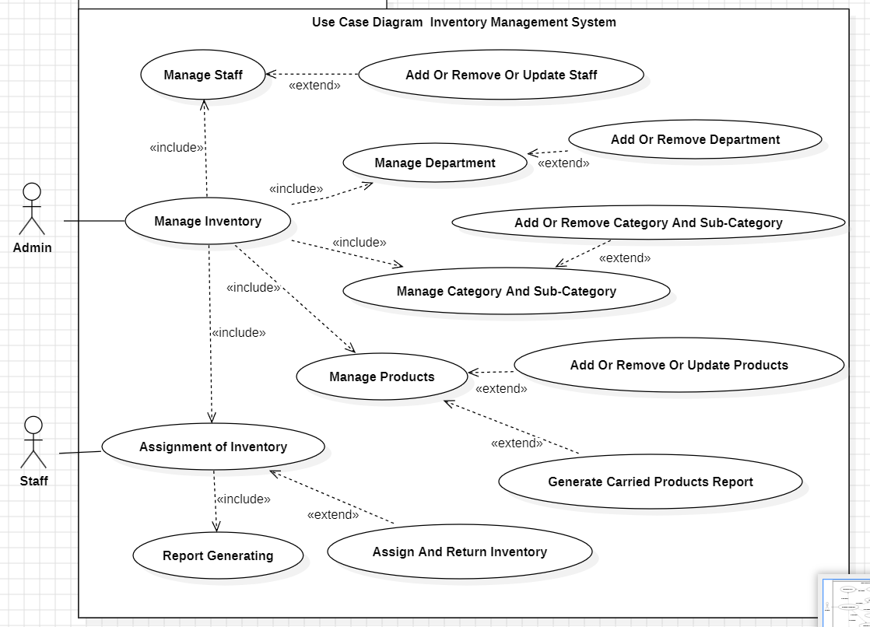

**Sequence Diagram**

**Sequence digram for login(**staff**)**

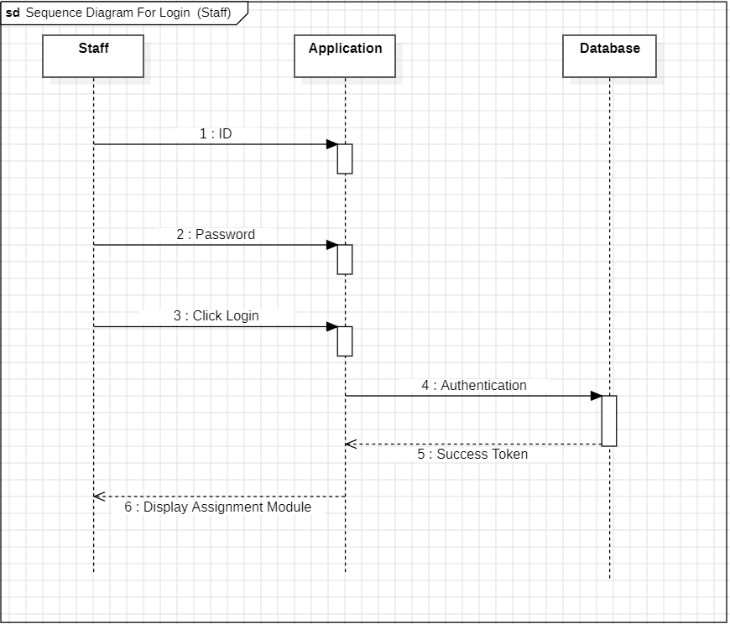

**Sequence digram for login(Admin)**

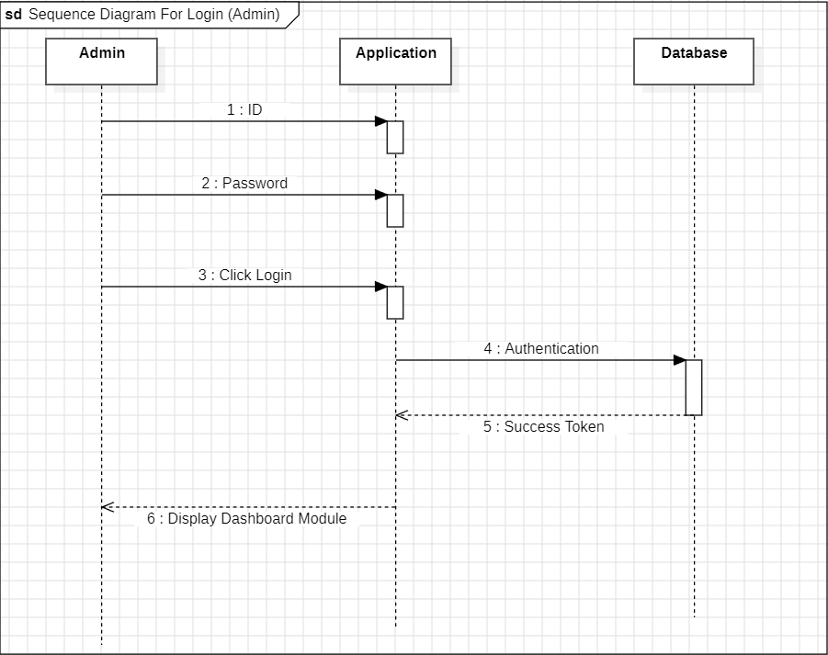

**Activity Diagram**

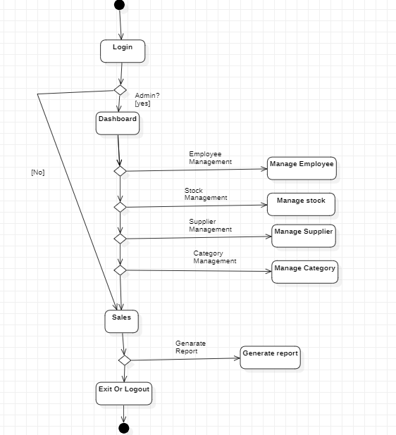

**Class Diagram**

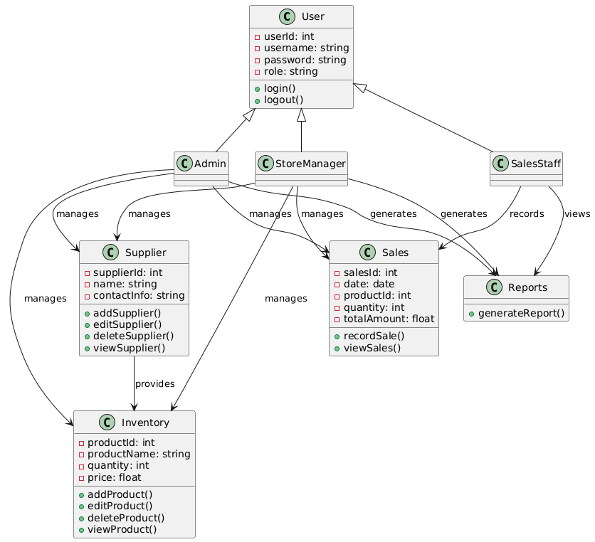

**Object Diagram**

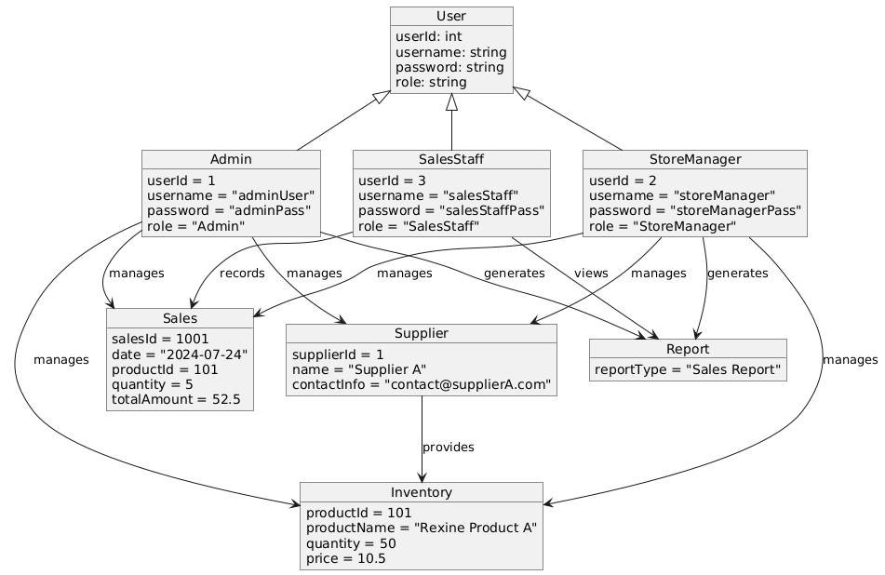

**Context (DFD) Diagram**

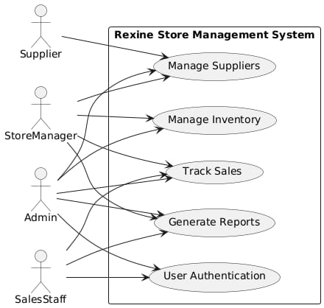

**Chapter 6. RESULTS**

**Login Page**

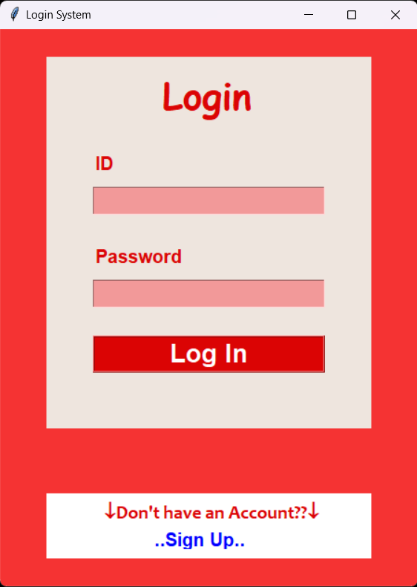

**Sign-Up Page**

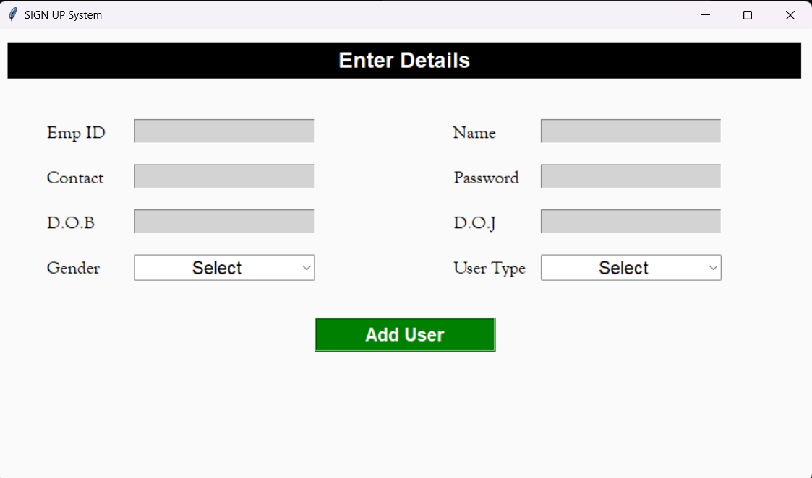

**Admin Sign-Up & Login**

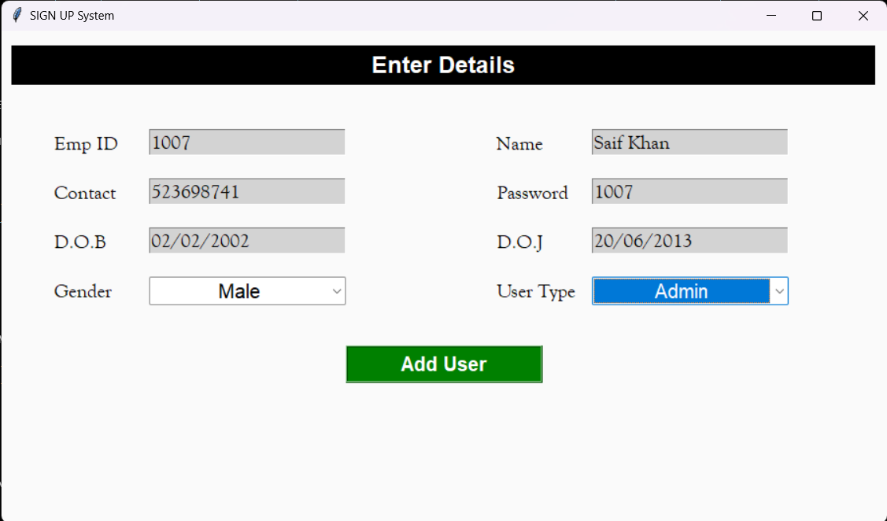

**Employee Added**

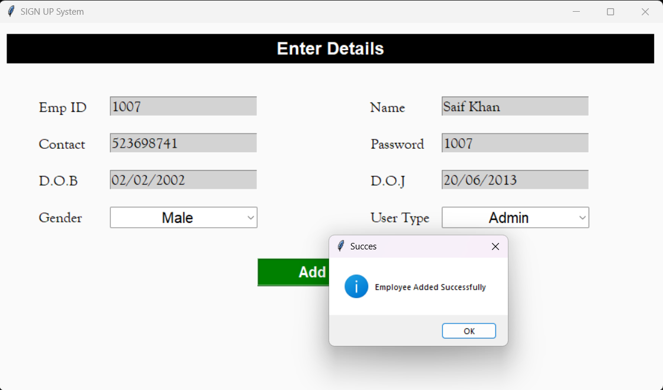

**Login For Admin**

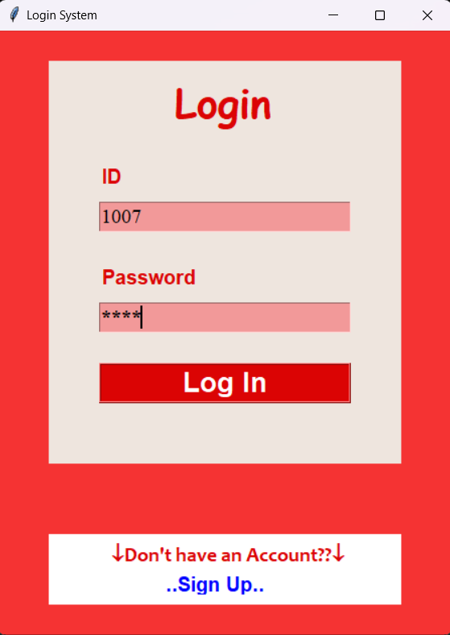

**After Admin Login**

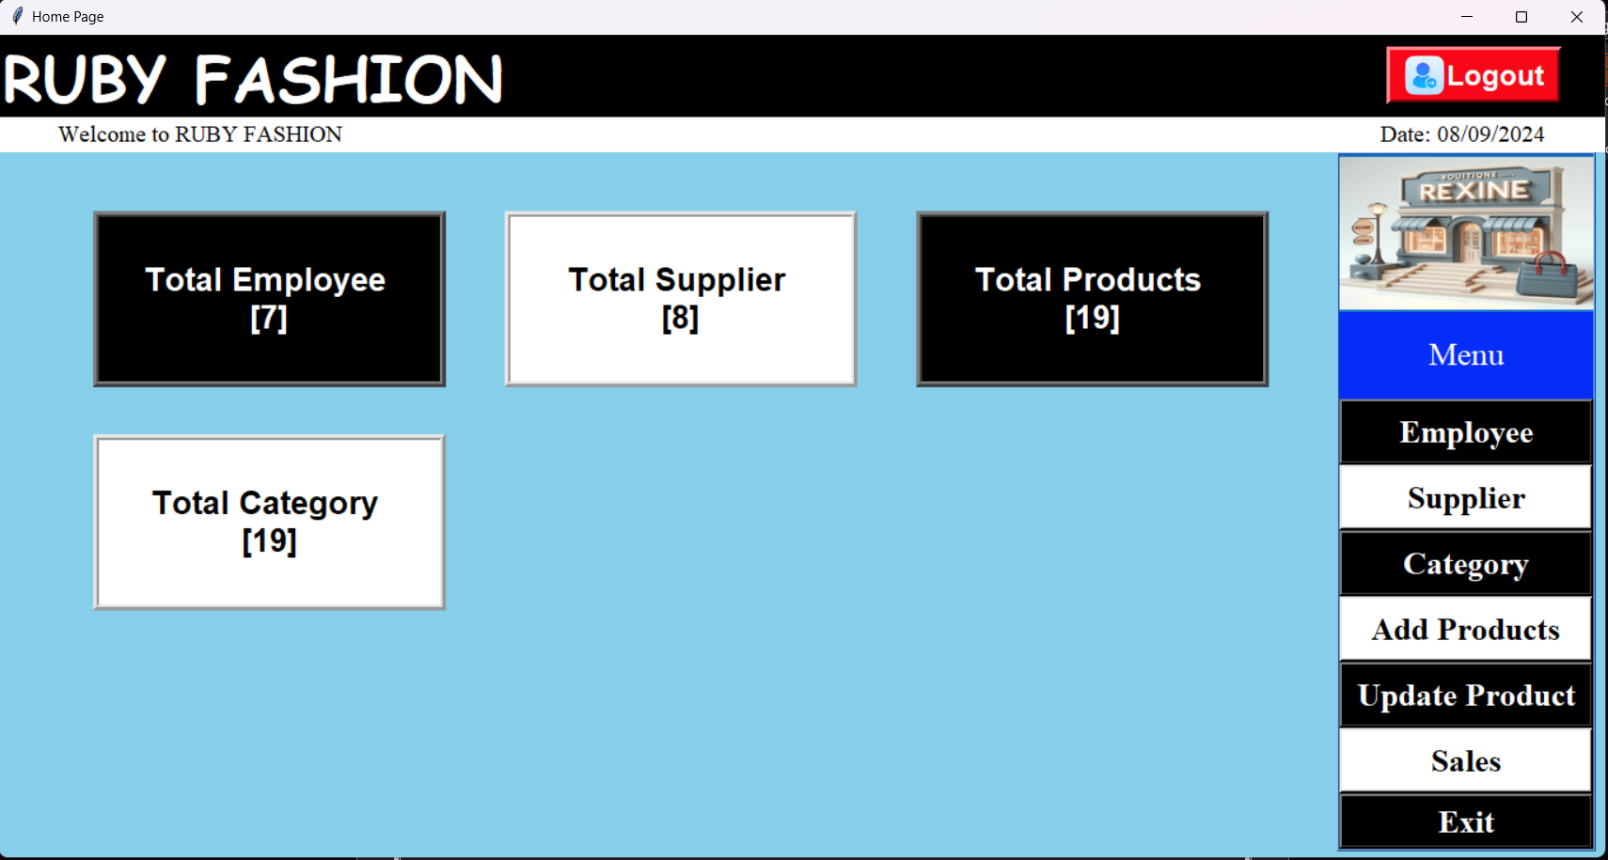

**Employee Sign-Up & Login**

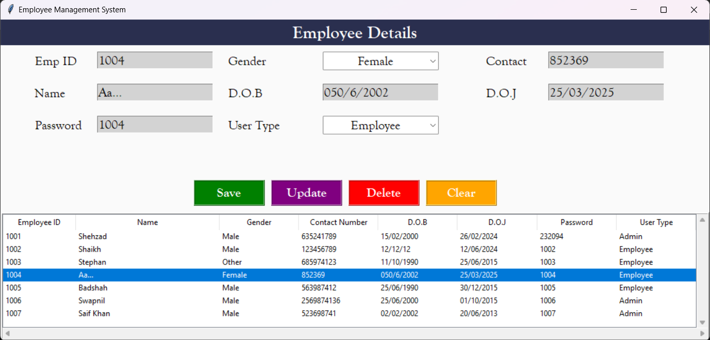

**Login For Employee**

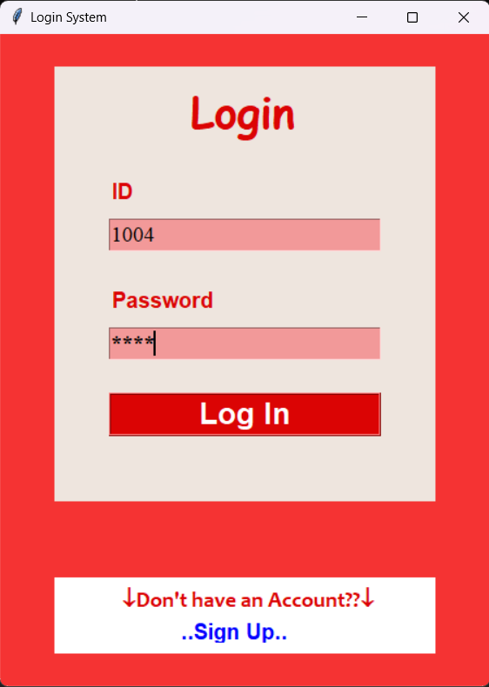

**After Employee Login**

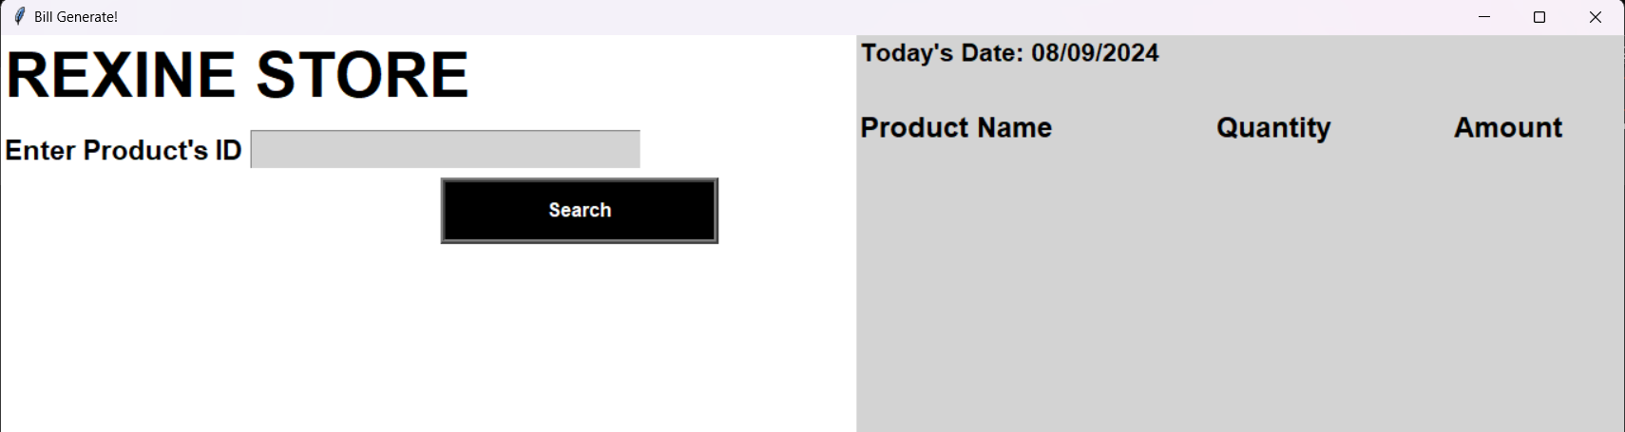

**Home Page**

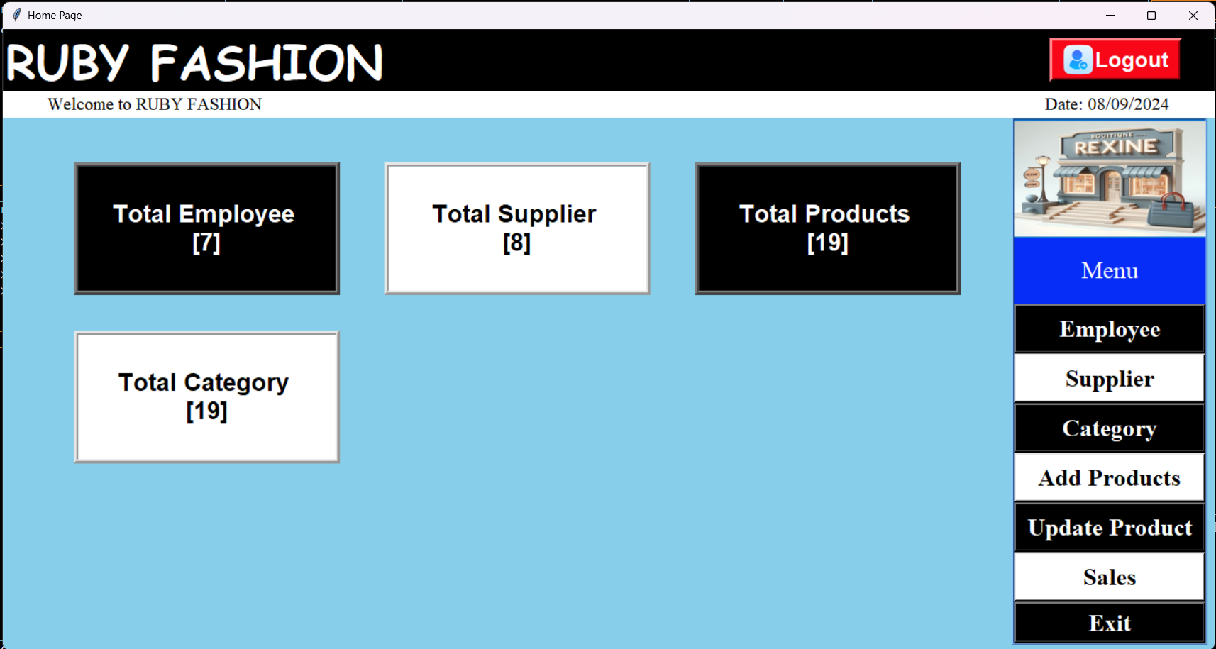

**Add a Product** 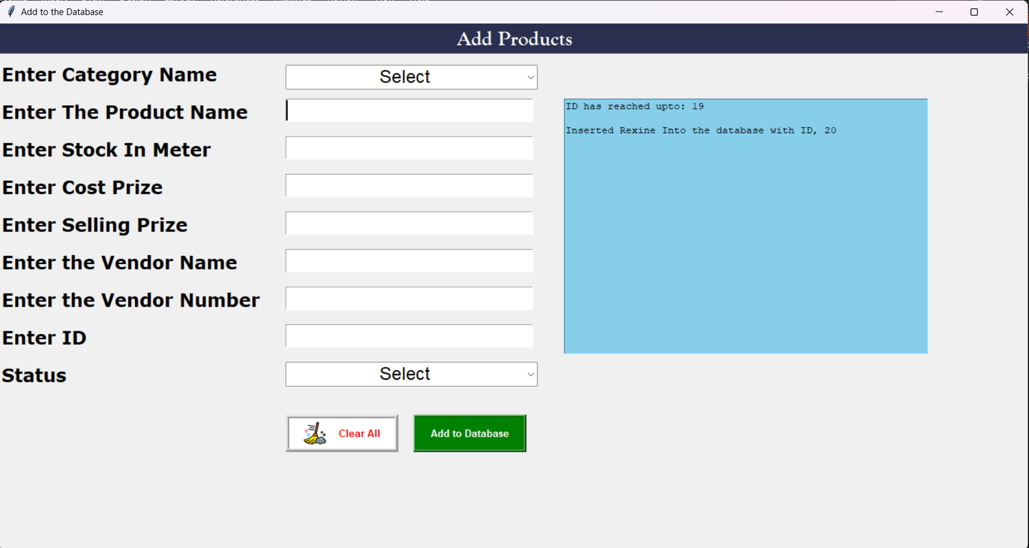

**After Added Product**

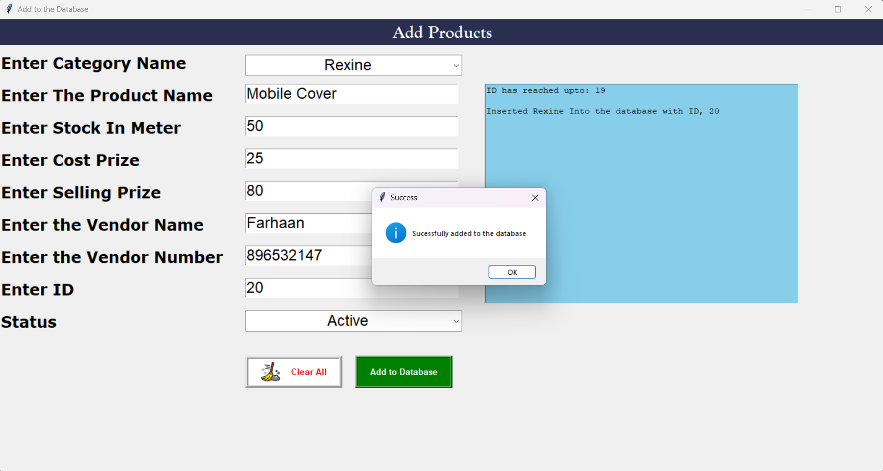

**Update A Products**

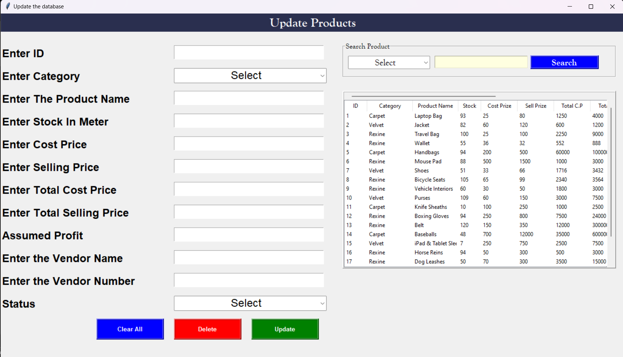

**After Updated**

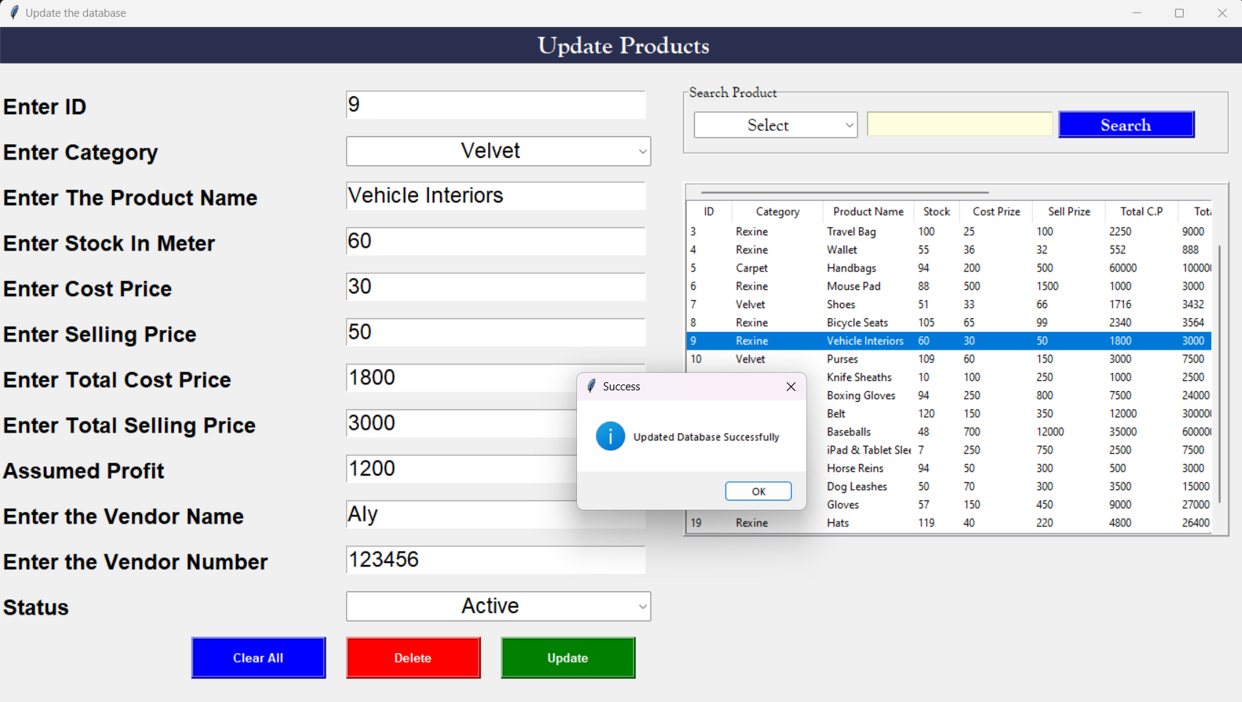

**Sales Page**

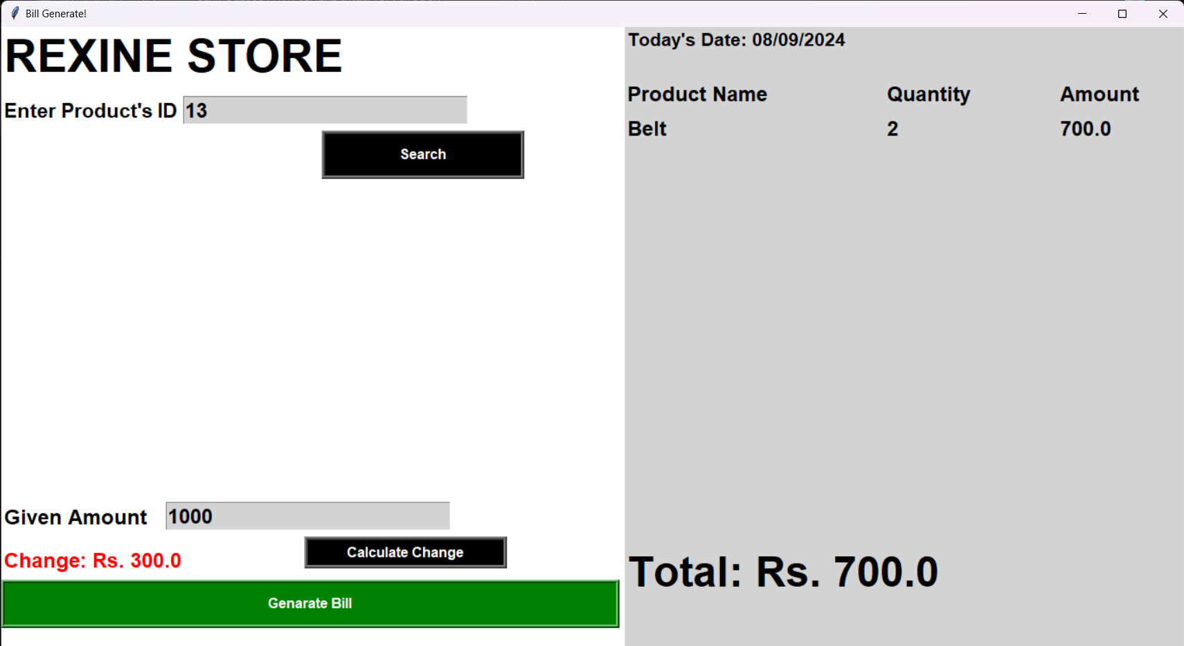

**Here Is The Bill Of Customer**

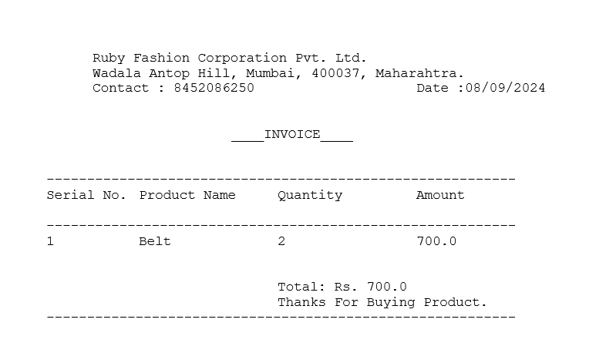

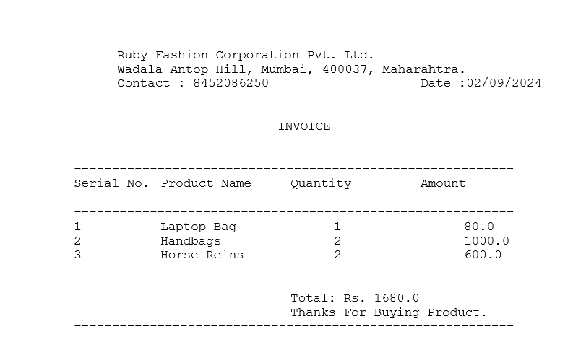

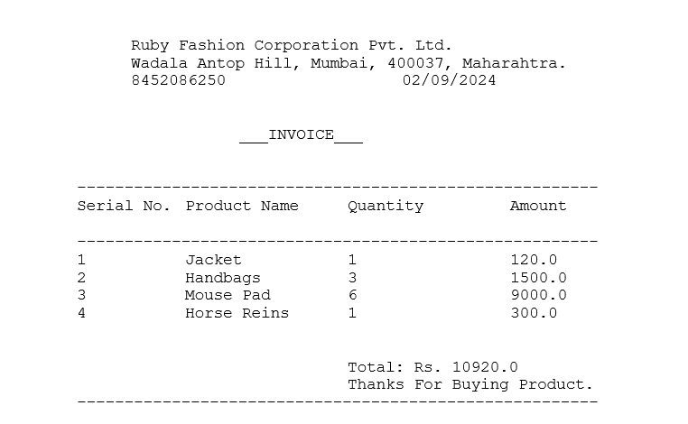

**Employee Page**

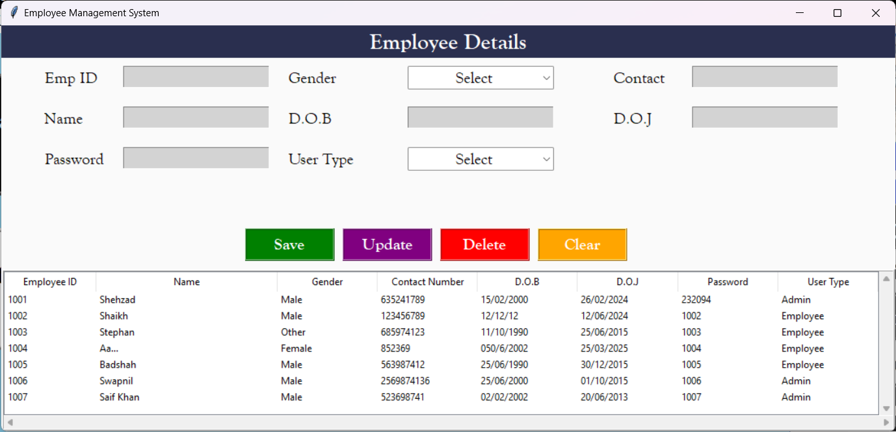

**Category Page**

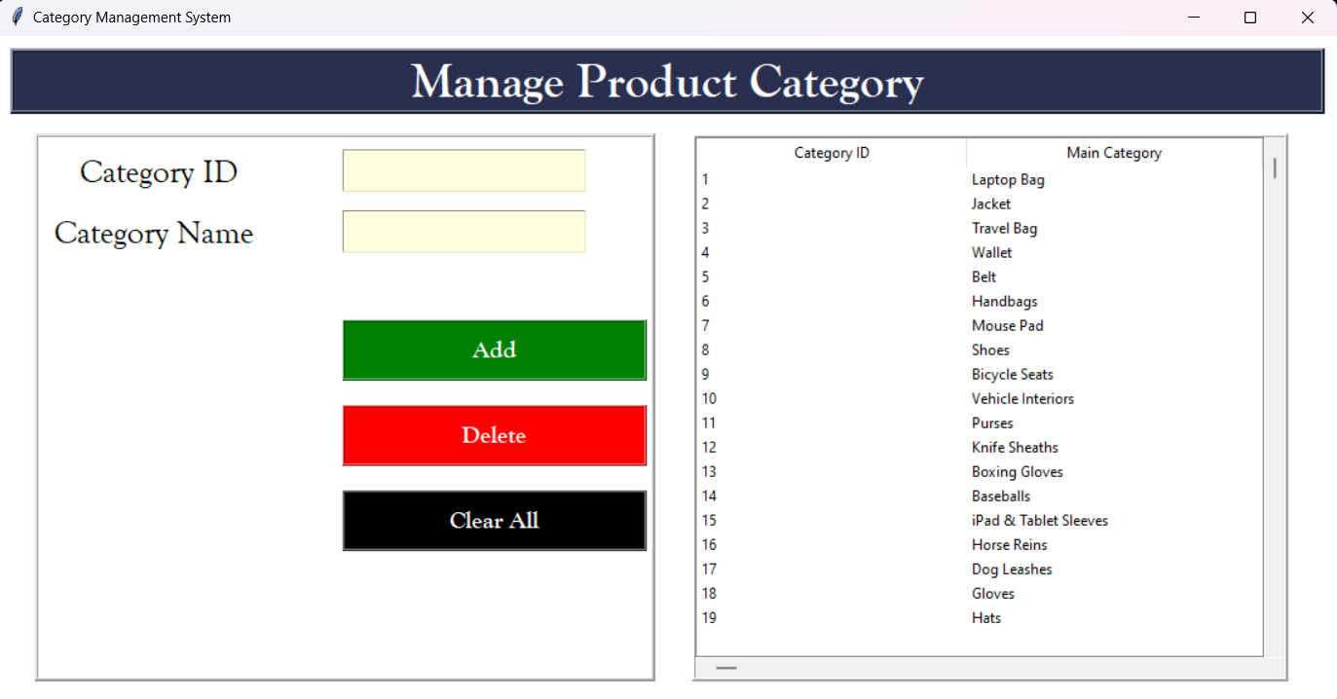

**Adding Category ID By 20**

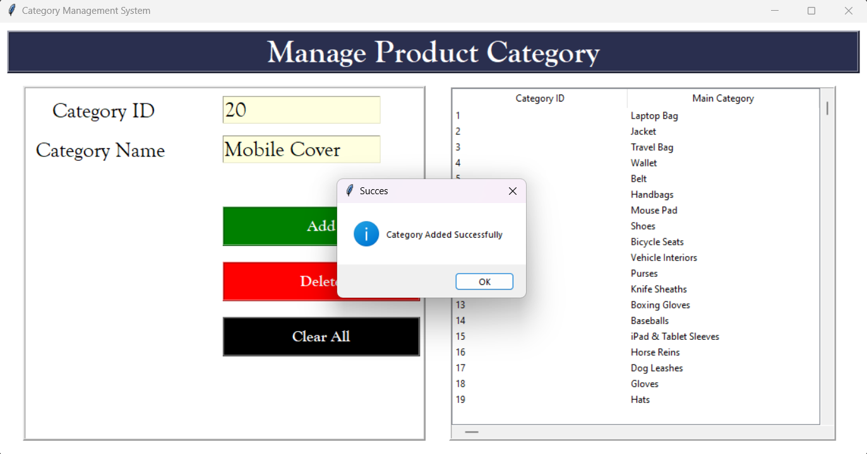

**For Deleting ID 20, Click On Delete Button**

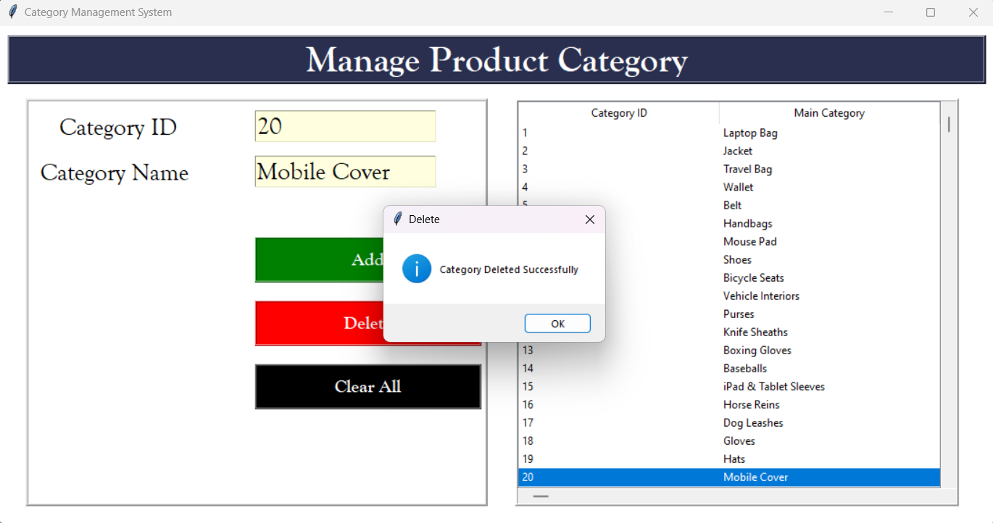

**Supplier Page**

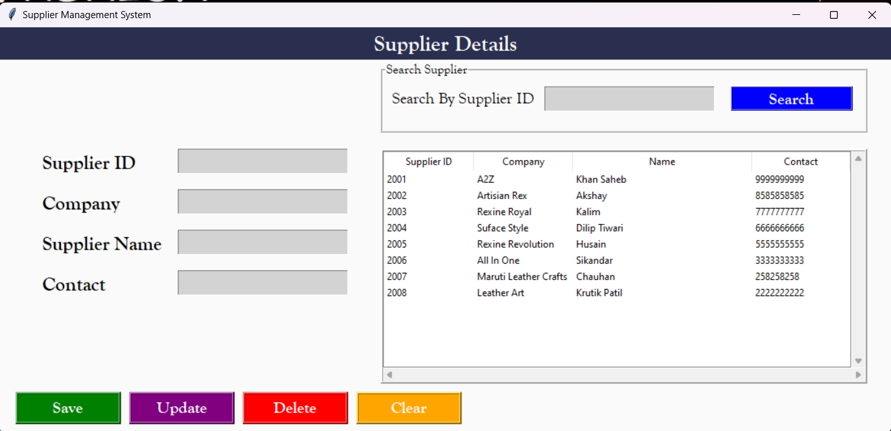

**Add New Supplier**

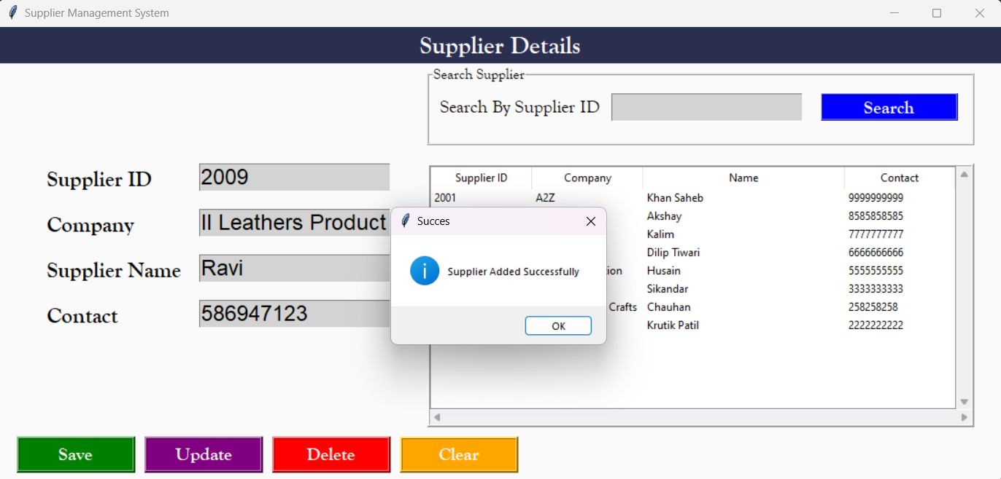

**Update Supplier Details**

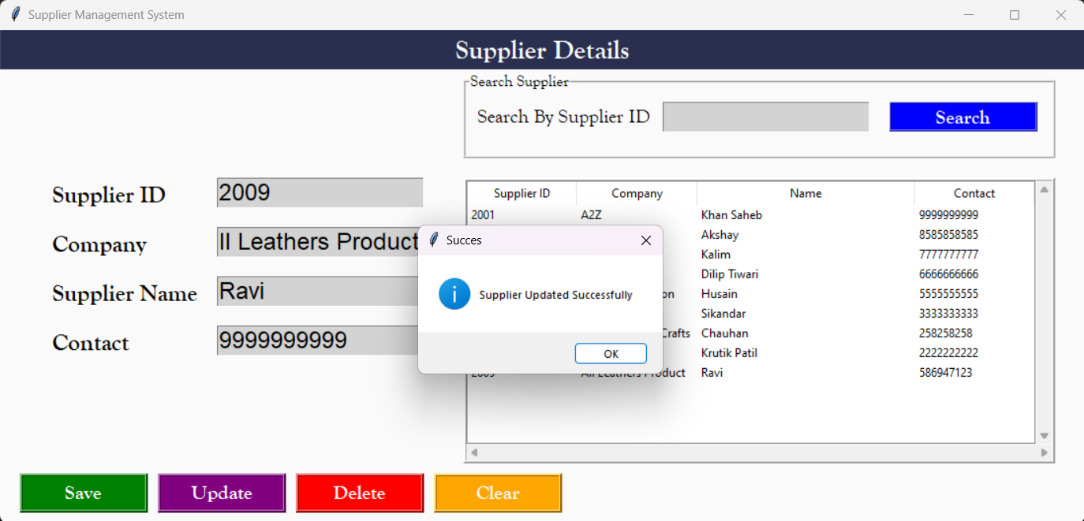

**Delete Supplier**

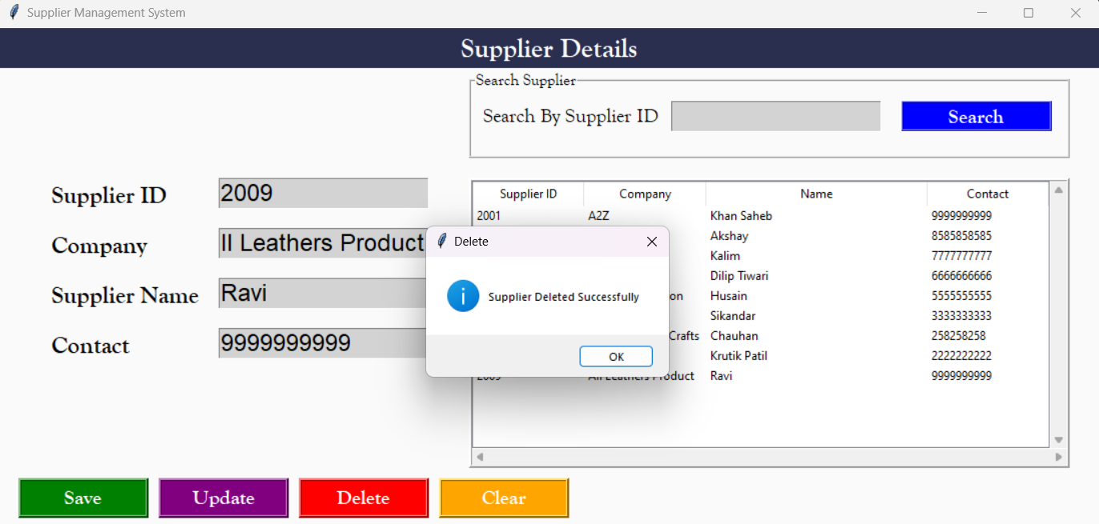

**For Logout, Click On Logout Button**

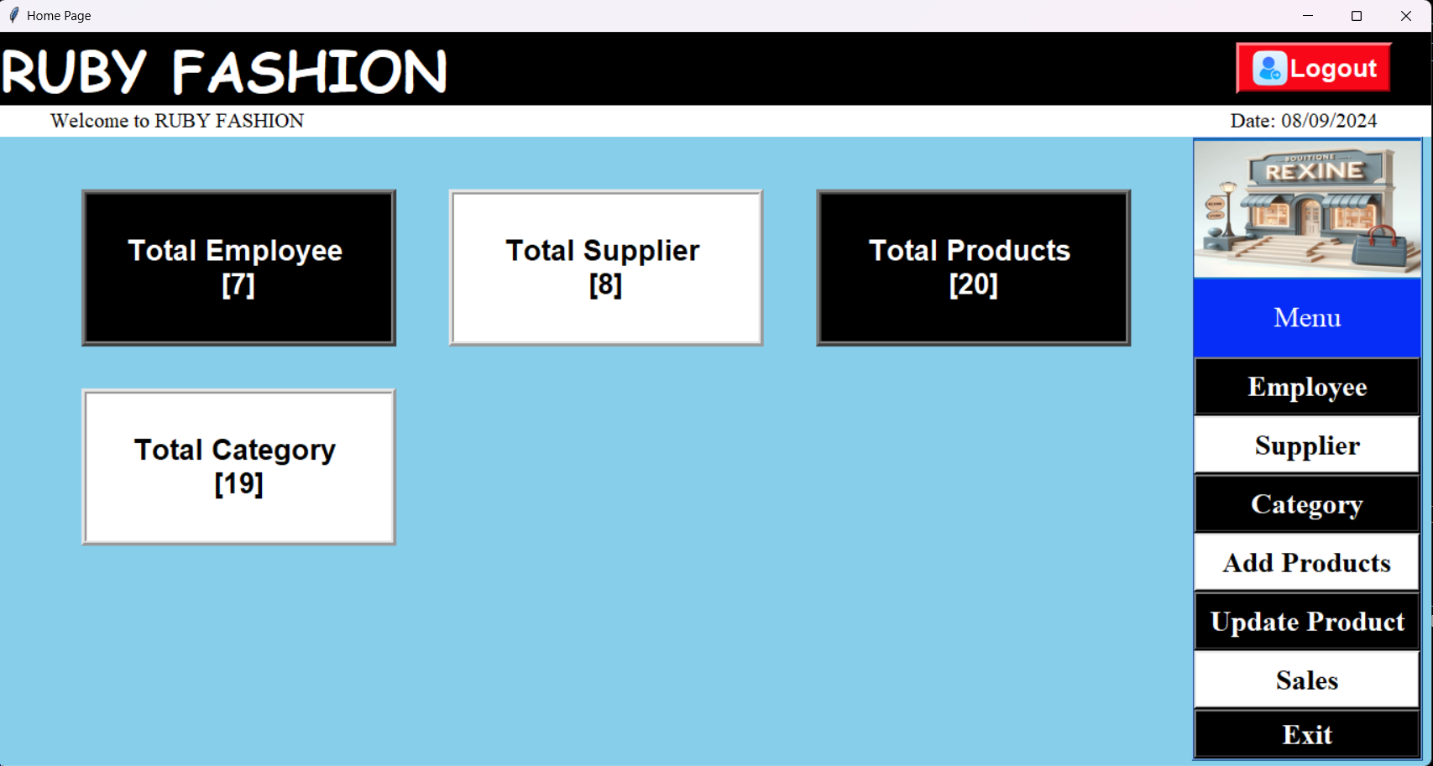

**Then We Will Go To Login Page**



**While Clicking Exit Button, It Will Close The Root**



**DATABASE FOLDER**

**Database Structure**

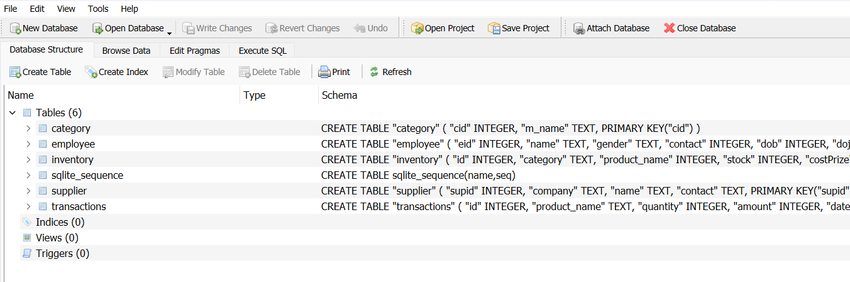

**Drop Down Button**

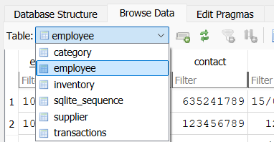

**Employee Details Table** 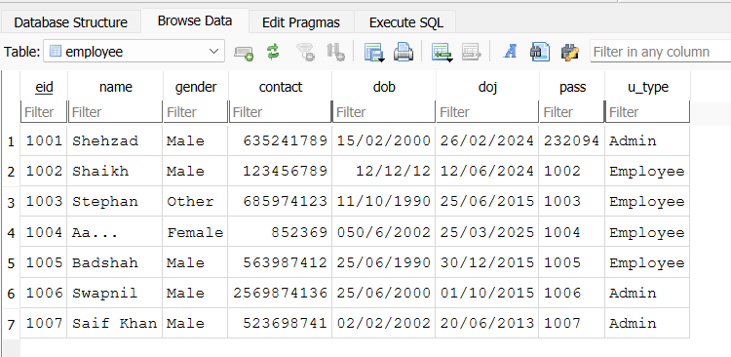

**Inventory Table**

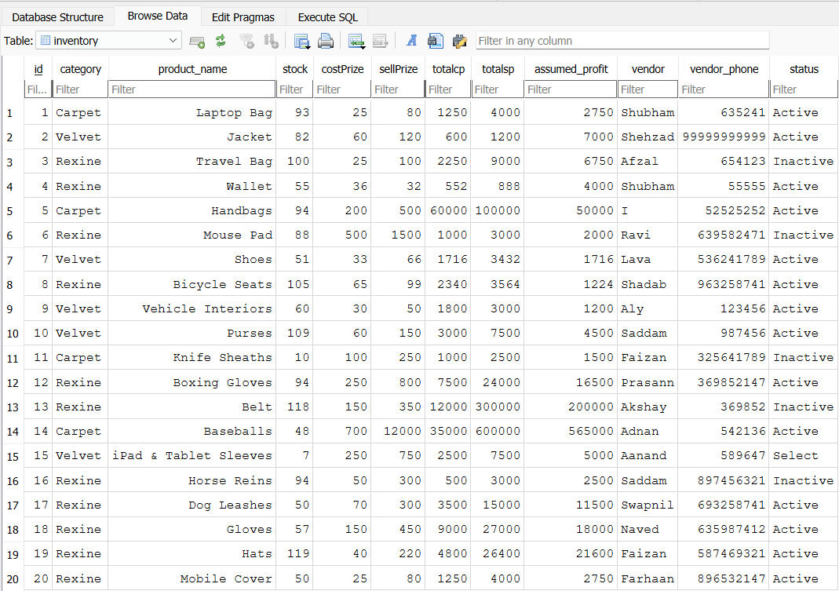

**Supplier Details Table**

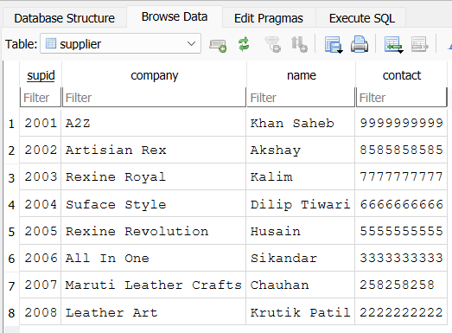

**Transactions Record Table**

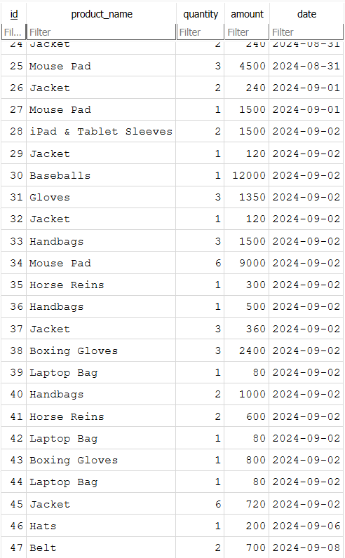

**Chapter 7. CONCLUSION AND FUTURE SCOPE**

**7.1 Conclusion**

The Rexine Store Management System plays a pivotal role in optimizing the operations of a rexine store. Through efficient management of inventory, sales, customers, and suppliers, the system ensures smooth and streamlined business processes. It offers a range of functionalities, including product management, sales processing, customer relationship management, supplier interactions, and robust reporting capabilities.

By conducting positive testing, we have ascertained that the system performs well under normal conditions. It can accurately handle tasks such as product addition, inventory updates, sales transactions, and generating various reports. Moreover, the system demonstrates excellent user authentication, ensuring that only authorized personnel can access and manipulate sensitive data. Additionally, the implementation of features like search functionality and data backup and recovery enhances user experience and data security.

Furthermore, negative testing has been instrumental in identifying potential vulnerabilities and weaknesses within the system. By subjecting the system to various adverse conditions, such as invalid data inputs, out-of-stock scenarios, unauthorized access attempts, and network failures, we have tested its resilience. The Rexine Store Management System has proven its robustness by appropriately handling errors, preventing unauthorized access, ensuring data integrity, and recovering gracefully from unexpected interruptions.

In essence, the Rexine Store Management System not only enhances the efficiency and accuracy of day-to-day operations but also provides a secure and reliable platform for managing critical business processes. Its positive features ensure a seamless user experience, while the successful handling of negative scenarios showcases its reliability and resilience in challenging situations. As a comprehensive solution, the system stands as an invaluable asset for any rexine store, facilitating effective management and contributing significantly to the overall success of the business.

**7.1.1 Advantages**

Rexine Store Management System (RSMS) can offer various advantages to businesses in the rexine industry.

**Efficient Inventory Management:**

RSMS helps in tracking rexine rolls, sheets, and related products efficiently. It maintains accurate stock levels and reduces the chances of overstocking or stockouts.

**Streamlined Sales Process:**

The system simplifies the sales process, allowing for easy product searches, quick order processing, and generating invoices. It enhances the speed and accuracy of transactions.

**Effective Supplier Management:**

RSMS enables businesses to manage interactions with suppliers, track orders, and maintain a smooth supply chain. This ensures a steady supply of rexine materials.

**Enhanced Security:**

RSMS allows role-based access control, ensuring that only authorized personnel can access sensitive information. This improves data security and confidentiality.

**Cost Savings:**

By automating various tasks, businesses can save costs related to labor, paperwork, and operational inefficiencies. It leads to overall cost savings in the long run.

**7.1.2 Limitations**

Rexine Store Management System (RSMS) offers numerous advantages, it also has certain limitations and challenges. Here are some common limitations associated with RSMS:

**Complexity**: RSMS can be complex, especially if it's highly customized or integrated with other systems. Complexity might lead to difficulties in implementation, maintenance, and user adoption.

**Data Security Concerns:** Storing sensitive customer data, sales records, and inventory details electronically poses security risks. If not properly secured, this data can be vulnerable to hacking, data breaches, or unauthorized access.

**Dependency on Technology:** RSMS relies heavily on technology. System downtimes, software bugs, or hardware failures can disrupt operations and cause inconvenience to customers.

**Data Loss:** Despite regular backups, there is always a risk of data loss due to unforeseen circumstances such as natural disasters, hardware failures, or software glitches. Regular backup procedures are necessary to mitigate this risk.

**7.2 Future Enhancement**

The future enhancement of a Rexine Store Management System (RSMS) can involve implementing advanced features and technologies to further streamline operations, improve customer experience, and stay ahead in the competitive market. Here are some potential future enhancements for an RSMS:

**Mobile Application:** Develop a mobile app version of the RSMS to allow customers to browse products, place orders, and track their purchases from their smartphones. This enhances customer convenience and expands the store's reach.

**E-commerce Integration:** Integrate the RSMS with e-commerce platforms to enable online sales. This integration can attract a broader customer base and provide 24/7 access to products, boosting sales and revenue.

**Customer Relationship Management (CRM):** Enhance the CRM capabilities of the system. Implement features like personalized product recommendations, customer feedback analysis, and loyalty programs to strengthen customer relationships and improve customer retention.

**Chatbots and Virtual Assistants:** Implement chatbots or virtual assistants on the website or mobile app. These AI-driven assistants can handle customer inquiries, provide product information, and assist in the purchasing process, enhancing customer support.

**Chapter 8. REFERENCES**

**Tkinter:**

<https://www.javatpoint.com/python-tkinter>

**Sqlite Database:**

<https://www.tutorialspoint.com/sqlite/sqlite_overview.htm>

**DB Browser:**

<https://en.wikipedia.org/wiki/SQLite>

**Idle:**

<https://en.wikipedia.org/wiki/Visual_Studio_Code>

**Star UML:**

<https://staruml.io/>